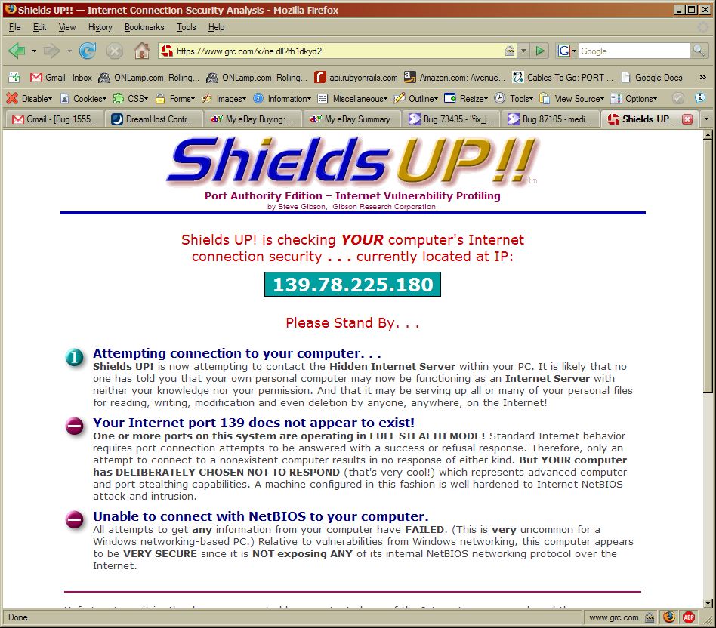
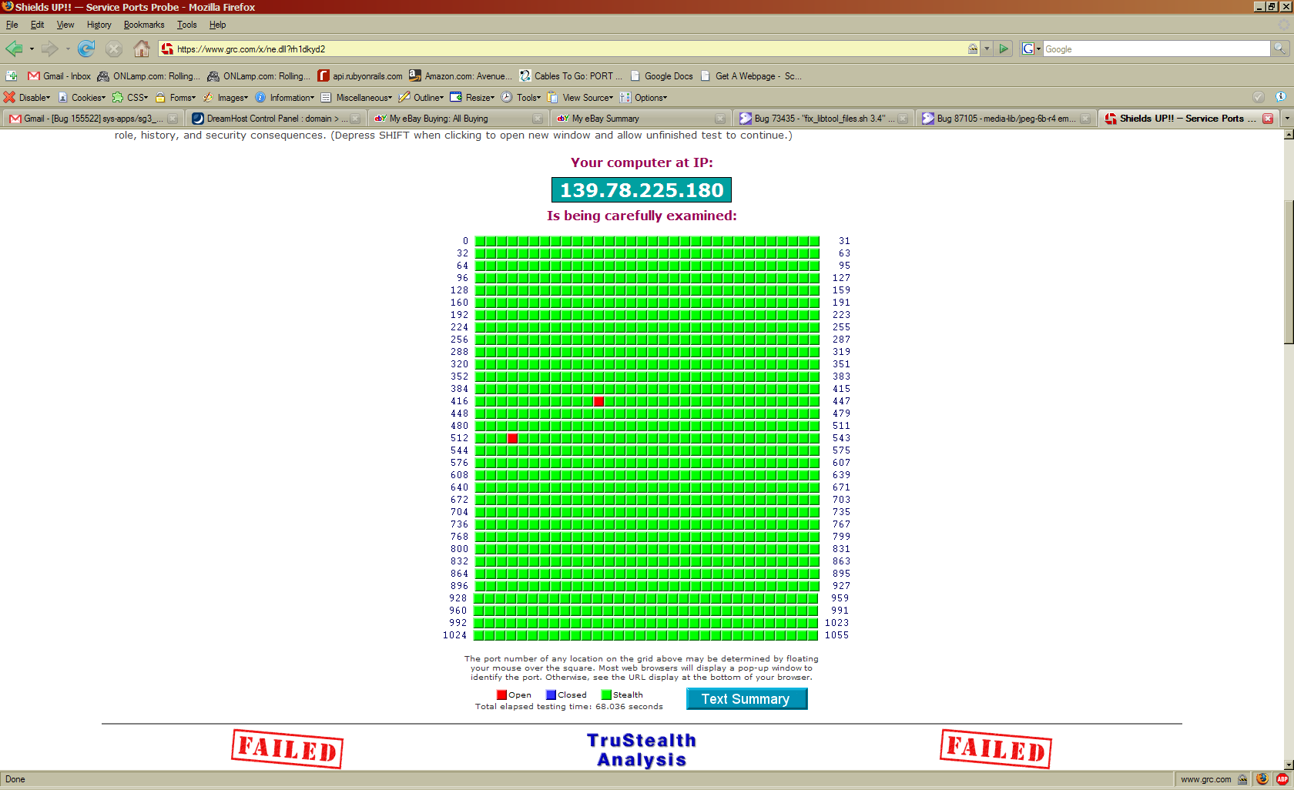
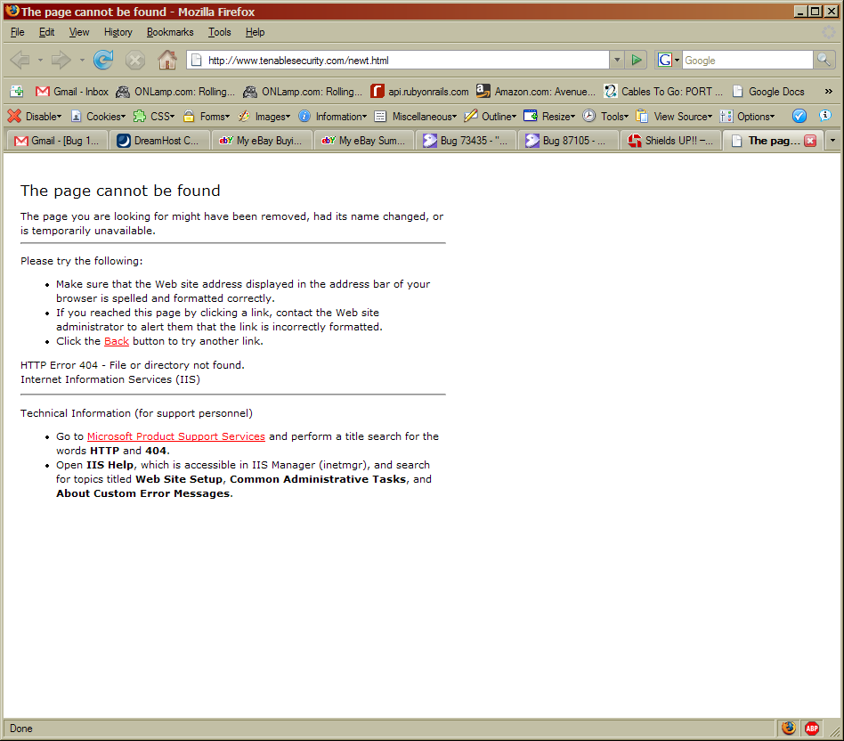

Summary

ShieldsUP! has always been a tool I’ve used. I like it, and I like the detailed port descriptions that Steve Gibson posts. I’ve got a few ports open, as you can see, which are related to my Internet-shared printer. The URL in the book is a 404, but I like ShieldsUP! so much that I’d probably keep using it anyways (even if this new scanner is better). It’s also not a web based scanner as far as I can tell, and I have to have a web-based scanner. Installing stuff is no fun.

